Project Design Phase-II
Technology Stack (Architecture & Stack)

Date | 28 September 2026
Team ID | 6ab221341
Project Name | Implement Client Scripts & UI Policy (Incident)
Maximum Marks | 4 Marks

Technical Architecture:
The technical architecture of the proposed solution is based on the ServiceNow Cloud platform. The user accesses the ServiceNow Incident Form through a web browser. Client Scripts perform client-side validation and dynamic form actions, while UI Policies control field visibility, mandatory status, and read-only behaviour. The processed incident information is stored in the ServiceNow Incident Table. The Administrator configures and manages the Client Scripts and UI Policies.

Example: ServiceNow Incident Management using Client Scripts and UI Policies
Reference:
- https://developer.servicenow.com/dev.do

- https://developer.servicenow.com/print_page.do?category=learning-module&identifier=CSS_About_zurich,new_to_servicenow&module=learning+plan&release=zurich&utm_source=chatgpt.com

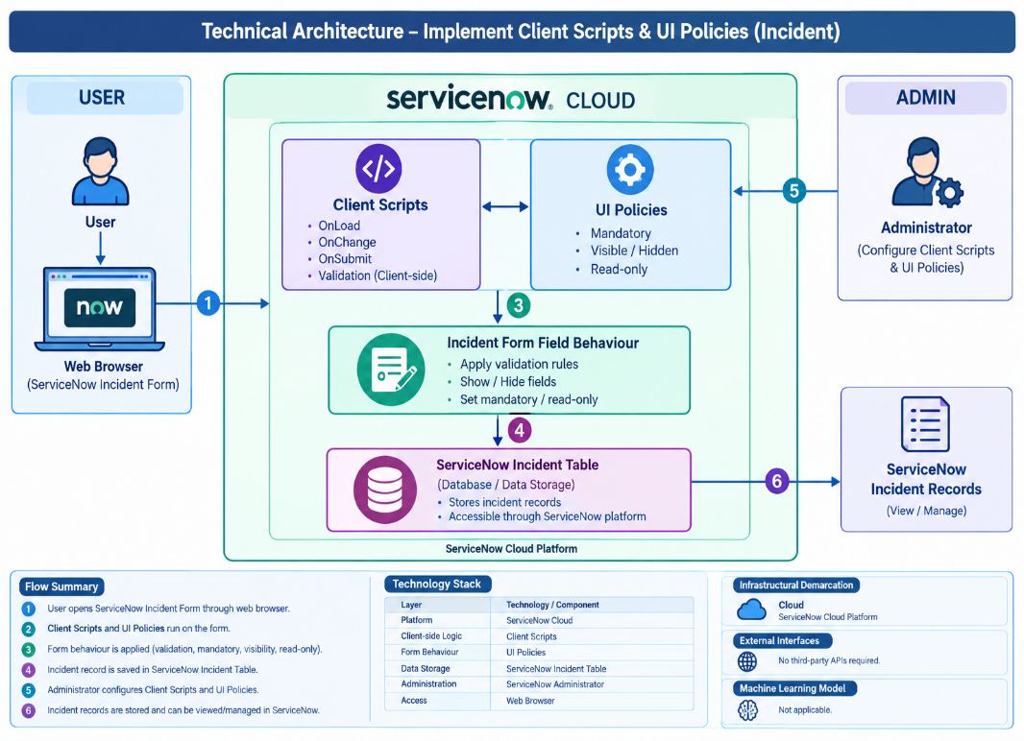
Guidelines:
- Include all the processes: Incident Form, Client Scripts, UI Policies, field validation, and incident record submission.
- Provide infrastructural demarcation: ServiceNow Cloud platform and web browser access.
- Indicate external interfaces: No third-party APIs or external interfaces are required.
- Indicate Data Storage components / services: ServiceNow Incident Table is used to store incident records.
- Indicate interface to machine learning models: Not applicable, as this project does not use any Machine Learning model.

Table-1 : Components & Technologies:
S.No | Component | Description | Technology
1 | User Interface | User interacts with the ServiceNow Incident application through a web browser. | ServiceNow Incident Form, Web Browser
2 | Application Logic-1 | Performs client-side validation and dynamic actions on the Incident form. | Client Scripts
3 | Application Logic-2 | Controls field visibility, mandatory status and read-only behaviour. | UI Policies
4. | Application Logic-3 | Processes and manages incident records based on configured rules. | ServiceNow Platform
5 | Database | Stores incident details and related information. | ServiceNow Incident Table
6 | Cloud Database | Provides cloud-based data storage for the ServiceNow application. | ServiceNow Cloud Database
7 | File Storage | No separate file storage is required for the core project. | Not Applicable
8 | External API-1 | No external API is required for the implementation. | Not Applicable
9 | External API-2 | No external API is required for the implementation. | Not Applicable
10 | Machine Learning Model | Machine Learning is not used in this project. | Not Applicable
11 | Infrastructure (Server / Cloud) | Application is deployed and accessed through the ServiceNow cloud platform. | ServiceNow Cloud

Table-2: Application Characteristics:
S.No | Characteristics | Description | Technology
1 | Open-Source Frameworks | No separate open-source framework is required; the project uses the ServiceNow platform. | ServiceNow Platform
2 | Security Implementations | Access is controlled using ServiceNow users, roles and permissions. | ServiceNow Access Controls
3 | Scalable Architecture | Additional Client Scripts and UI Policies can be configured as requirements increase. | ServiceNow Cloud
4 | Availability | The application is available whenever the configured ServiceNow instance is available. | ServiceNow Cloud
5 | Performance | Client-side scripts and UI Policies provide quick validation and field updates on the Incident form. | Client Scripts & UI Policies

References:
https://developer.servicenow.com/
https://developer.servicenow.com/print_page.do?category=learning-module&identifier=CSS_About_zurich%2Cnew_to_servicenow&module=learning+plan&release=zurich
https://developer.servicenow.com/dev.do?_escaped_fragment_=%2Flearn%2Flearning-plans%2Fxanadu%2Fnew_to_servicenow%2Fapp_store_learnv2_scripting_xanadu_exercise_create_ui_policies

